Part 1

1. Describe the energy store changes when a rocket firework is lit, goes up in the air and then falls back
to the ground. (4)

Chemical thermal kinetic gravitational kinetic thermal
(1 mark for each correct energy store change, maximum 4 marks)

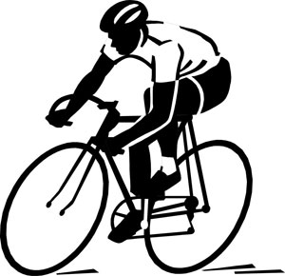
2. A cyclist is braking hard to avoid a collision.
Describe the energy store changes as the bicycle and rider decelerate to a stop. (3)

- Rider and bicycle have a store of kinetic energy (1)
- The energy store shifts to heat energy in the brakes and wheel rims due to friction (1)
- When the bicycle stops the heat store is dissipated into the environment (1)

3. When a battery stops working people often say the energy has been used up. Explain why this statement is not
correct. (2)

Energy cannot be used up as it cannot be created or destroyed (1)

The energy has been transferred into a less useful energy store (1)

4. The Sankey diagram shows the simple energy store transfers for a car.
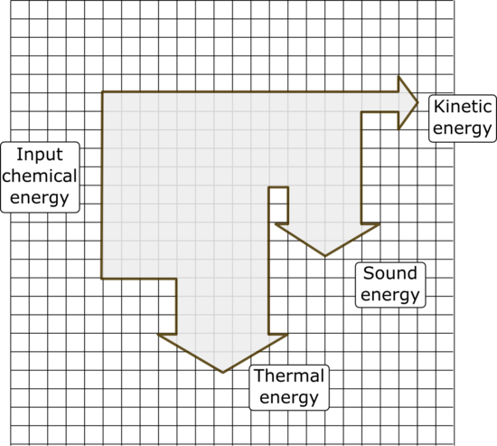

Chemical energy from the petrol = 20 000 J

- Calculate the amount of useful energy
transferred by the engine. (1)

4000 J (1) (each small square equates to 2000 J)

- What is the total amount of “wasted” energy
in the system? (1)

18 000 J (1) (thermal and sound)

5. An eagle has a mass of 4 kg and is flying at a velocity of 35 m/s. Calculate the kinetic energy of the bird. (3)

E_{k} = ½ m v² (1) E_{k} = ½ (4 x 35²) (1) E_{k} = 2450 J (1)

6. A 48 kg person diving off a cliff has 3500 J of stored gravitational potential energy. Calculate the height of the cliff (3)

E_{p} = m g h h = _ E_{p}_ (1) h = _3500_ (1) Height of cliff = 7.3m (1)
m g 48 x 10

Part 2

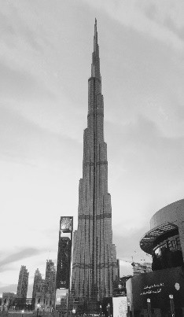
1. The lift in the world’s tallest building takes 64 s to reach a height of 828 m.
The maximum mass of the lift and passengers is 900 kg.
- Calculate the power of the lift. (3)
Power = work done (1) work = f x d = 9000 x 828 = 7 452 000 J (1)
time
Power = 7 452 000 = 116 438 W or 116.438 kW
64
- A service lift in this building is used to move furniture to apartments in the tower.
This lift has a 130 kW motor. If the maximum load for this lift is 2000 kg, how long will it take to reach the top of the building? (3)

Power = work done (1) time = work done (1) time = 20 000 x 828 = 127s (1)
time power 130 000

2. The diagram represents the energy transfers for an oil-fired power station.
Generator
Turbine
Water and steam
Oil

Energy transferred as movement
Useful energy out
X
Energy transferred as heat

- What is the useful energy out? (1)

Electrical energy (1)

- In what form will energy be “wasted” in this process? (1)

Thermal (internal) energy (1)

- What useful energy store is represented by the box labelled X? (1)

Movement or kinetic (1)

3. A company sells two types of electric drill.

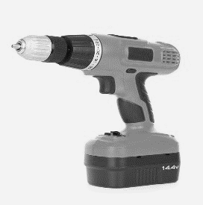
Drill A Drill B
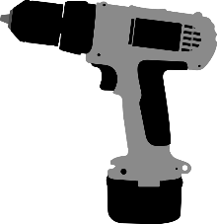

Drill A is a 300 W drill with an output power of 165 W.
Drill B is a 1100 W drill with an output power of 520 W.
Explain which drill is the more efficient at transferring useful energy? (3)

efficiency = useful power output (1)
total power input

Drill A efficiency = 165 = 0.55 Drill B efficiency = 520 = 0.47 (1)
300 1100

Drill A is more efficient at transferring useful energy (1)

4. Describe two ways you could increase the efficiency of a household central heating system. (2)

Lag pipes carrying hot water to reduce thermal energy loss

Buy a more efficient boiler
Re-use the waste thermal energy to pre-heat water (any 2 valid answers) (2)

